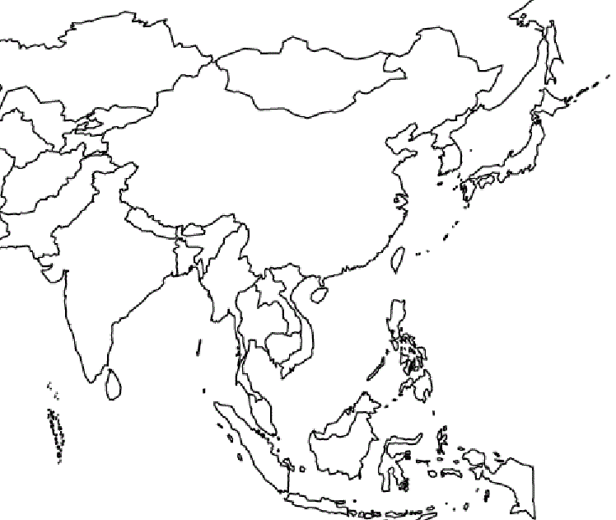
South East Asia Political and Physical Features

- Label all countries/physical features in Black
- Color Bodies of Water – Blue (8)
  - Ganges River
  - Huang He (Yellow River)
  - Yangtze (Chang Jiang) River
  - Bay of Bengal
  - Indian Ocean
  - Sea of Japan
  - South China Sea
  - Yellow Sea
- Color Deserts – Red (2)
  - Gobi Desert
  - Taklimakan Desert
- Color Mountains – Brown (1)
  - Himalayan Mountains
- Outline the Korean Peninsula in Purple (1)
- Outline all countries in Black
Pick a different color for each country that you need to know (6)

- China
- India
- Japan
- North Korea
- South Korea
- Vietnam
South East Asia Political and Physical Features

Name: ___________________________________ Period: ______ Score: __________
Physical/Political Features 5 points each. Following ALL directions 5 points.
- Label all countries/physical features in Black
- Color Bodies of Water – Blue (8)
  - Ganges River
  - Huang He (Yellow River)
  - Yangtze (Chang Jiang) River
  - Bay of Bengal
  - Indian Ocean
  - Sea of Japan
  - South China Sea
  - Yellow Sea
- Color Deserts – Red (2)
  - Gobi Desert
  - Taklimakan Desert
- Color Mountains – Brown (1)
  - Himalayan Mountains
- Outline the Korean Peninsula in Purple (1)
- Outline all countries in Black. Pick a different color for each country that you need to know (6)
  - China
  - India
  - Japan
  - North Korea
  - South Korea
  - Vietnam

